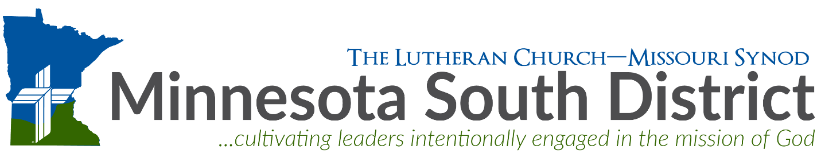

OVERVIEW
MN Statute 604.20 Background Check Procedure for Congregations & Schools

Background Check Packet Contents for Congregations and Schools
- Form B –(Sample) Letter to the Called Worker
- Form C -Authorization to Release Information
- Form D -Identification of Employers*
- Form F –(Sample) Letter to Employers
- Form G -Employer Report
- Form H -Instructions: Completing Employer Report
- Form J -Verification of Completion
- Chapter 604.20 -Action for Sexual Exploitation: Psychotherapists
- Informational Memorandum Minnesota Statute §604.20 (also called Chapter 604.20)

*An “Employer” as defined in the Informational Memorandum

Step 1:
After the Called Worker has accepted the Call, the designated member of the congregation’s Call Committee should begin the MN Statute §604.20 background check process. The Called Worker should be mailed/emailed these items:
- Form B –(Sample) Letter to the Called Worker
- Note that Form B –(Sample) Letter to the Called Worker will need to be properly addressed and blanks filled in in preparation for sending this information.
- Form C -Authorization to Release Information
- Form D -Identification of Employers
- Informational Memorandum Minnesota Statute §604.20 (also called Chapter 604.20)
- Chapter 604.20 -Action for Sexual Exploitation: Psychotherapists
It is acceptable to email all of this information as file attachments to the Called Worker.

Step 2:
After the Called Worker has returned the Form C - Authorization to Release Information and the Form D -Identification of Employers, send the following to each of the identified employer(s):
- Form F –(Sample) Letter to Employers
- COPY of Form C -Authorization to Release Information
- Note that Form F -Sample Letter to Employers will need to be properly addressed and blanks filled in in preparation for sending this information.
- Form G -Employer Report
- Form H -Instructions: Completing Employer Report
- Informational Memorandum Minnesota Statute §604.20
- Chapter 604.20 -Action for Sexual Exploitation: Psychotherapists
It is acceptable to email all of this information as file attachments to the Called Worker.

Step 3:
After every Form G -Employer Report has been returned and is clear, it is necessary to mail, in hard copy, (on congregation’s letterhead) the following to the District President:
- Form J -Verification of Completion
All other information gathered in the background check process should be retained by the calling congregation.

Address: MNS District – LCMS
President’s Office
14301 Grand Ave. S.
Burnsville, MN 55306-5707

